Nightmare Distress

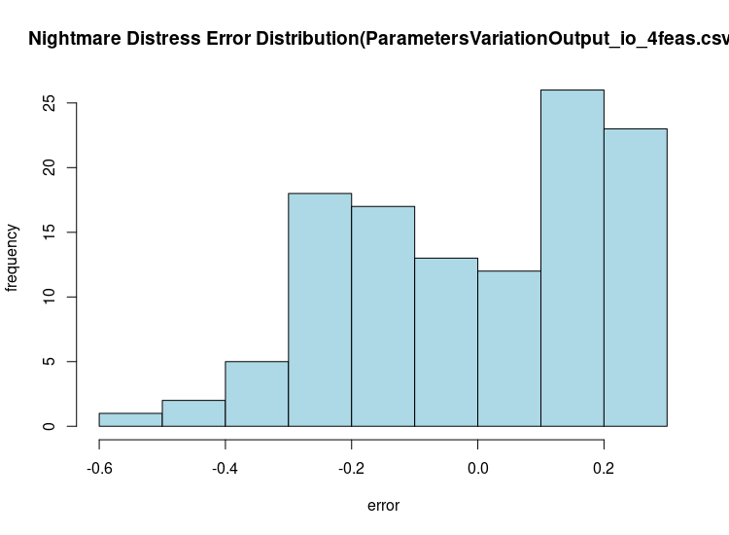
[1] "mse: 0.0377527143221643"
[1] "mean: -0.0129058169043264"
[1] "sdv: 0.194705348624508"
[1] "skewness: -0.48930089054695"
[1] "kurtosis: 2.25901109203336"
[1] "two-tailed t-test"

One Sample t-test

data: resid
t = -0.71697, df = 116, p-value = 0.4748
alternative hypothesis: true mean is not equal to 0
95 percent confidence interval:
-0.04855811 0.02274647
sample estimates:
mean of x
-0.01290582

Nightmare Effects

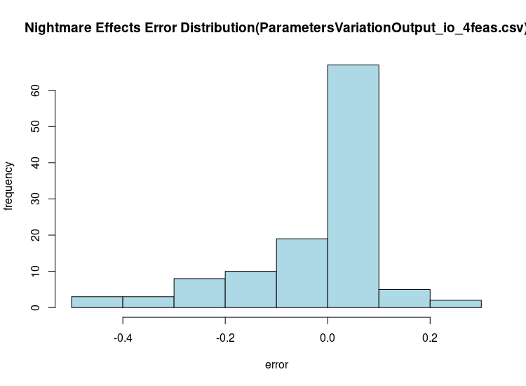
[1] "mse: 0.0201435250357592"
[1] "mean: -0.00899720035077179"
[1] "sdv: 0.142251638507261"
[1] "skewness: -1.42645603635613"
[1] "kurtosis: 4.52642159766427"
[1] "two-tailed t-test"

One Sample t-test

data: resid
t = -0.68414, df = 116, p-value = 0.4953
alternative hypothesis: true mean is not equal to 0
95 percent confidence interval:
-0.03504475 0.01705035
sample estimates:
mean of x
-0.0089972

DASS Anxiety
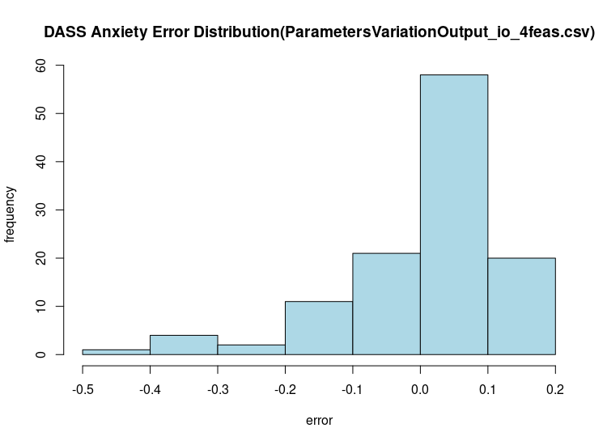
[1] "mse: 0.014993967882447"
[1] "mean: 0.0109086471385746"
[1] "sdv: 0.122487557711055"
[1] "skewness: -1.62375138551407"
[1] "kurtosis: 5.89297334797378"
[1] "two-tailed t-test"

One Sample t-test

data: resid
t = 0.96332, df = 116, p-value = 0.3374
alternative hypothesis: true mean is not equal to 0
95 percent confidence interval:
-0.01151992 0.03333721
sample estimates:
mean of x
0.01090865

Nightmare Frequency
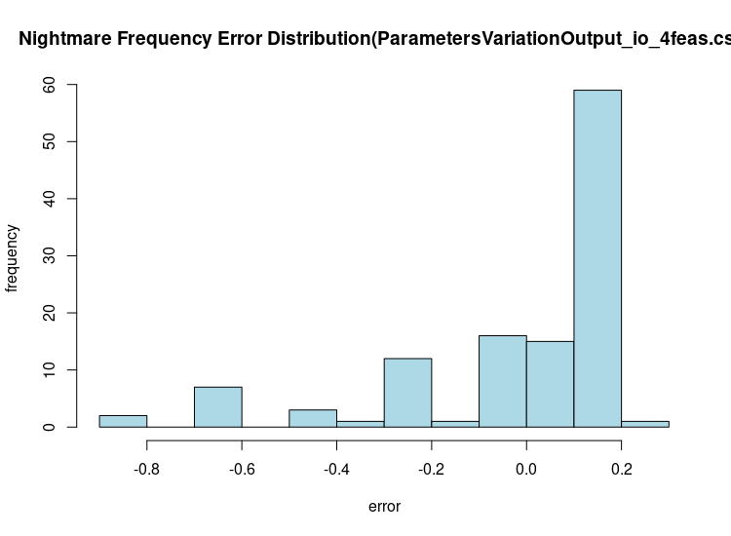
[1] "mse: 0.063244399392373"
[1] "mean: -0.0353360531747629"
[1] "sdv: 0.250060410638923"
[1] "skewness: -1.76020885328889"
[1] "kurtosis: 5.19505996410213"
[1] "two-tailed t-test"

One Sample t-test

data: resid
t = -1.5285, df = 116, p-value = 0.1291
alternative hypothesis: true mean is not equal to 0
95 percent confidence interval:
-0.08112435 0.01045224
sample estimates:
mean of x
-0.03533605

